Psychosocial Risk Management Report
Test Org

Outcome measures: Work Engagement · Burnout · Psych Distress
Organisation size: 1,200
Date: 25/09/2026
Prepared by: Pat Egan

Generated with Prior Work · priorwork.au · © 2026 Prior Work. Released under CC BY-NC-SA 4.0.

Contents

Executive Summary
Context and Approach
Evidence and interpretation
Findings and What They Mean
The starting position
Reduce excessive workload while preserving useful work
Reduce interference with life outside work
Strengthen purpose and acknowledge contribution
Address emotionally demanding work where it occurs
Combined approaches involve a choice of emphasis
Recommended Next Steps
1. Establish local priorities and decision authority
2. Protect workers promptly where harm is established
3. Build longer-term improvements around workers’ experience
4. Record the baseline, test changes and review progress
Appendix – Supporting Material
A1 – How the Factors Connect
A2 – Starting Model Estimates
A3 – Simple Scenarios: One Factor at a Time
A4 – Combined Scenarios: Factors Moved Together
A5 – Methodology and How to Read These Tables

Entries are clickable. For page numbers, right-click the list and choose Update Field.

Executive Summary
Test Org’s senior leaders should use this report to prioritise a local assessment and practical improvements to working conditions across its 1,200-worker workforce.
The supplied General Australian Workforce model has no recorded source or fitting coverage establishing local measurement. Prediction checking and uncertainty ranges are unavailable. Its scenarios assume everyone experiences the specified conditions; they are not forecasts of control effectiveness.
The main findings are:
- Low Role Overload reduces modelled high Burnout by about 15 percentage points and high Psych Distress by about 7 points. However, high Work Engagement falls slightly.
- Low Work Life Conflict reduces both adverse outcomes and increases high Work Engagement, supporting attention to work spilling into personal life.
- High Meaningful Work and high Recognition increase high Work Engagement by about 12 and 11 points respectively, with smaller reductions in adverse outcomes.
- Low Emotional Demand reduces high Burnout by about 9 points, without changing modelled engagement.
The next decision is not which modelled percentage to promise. It is where local conditions require action and which changes are feasible.
Leaders should appoint an accountable sponsor, establish the first local baseline and consult workers on these five factors. Confirmed harmful demands should be addressed promptly through changes to priorities, capacity, schedules or recovery arrangements. Longer-term redesign should preserve purposeful work, acknowledgement and existing supports.
Progress should be checked against the recorded local baseline, including whether pressure has shifted to other workers. Other factors remain available in Data Analytics at priorwork.au.

Context and Approach
This report gives Test Org’s senior leaders a starting point for choosing how to manage psychosocial risks and strengthen positive working conditions across its workforce of 1,200 workers. It focuses on work arrangements that may affect workers’ health and engagement, and on the local evidence needed before committing resources.
The supplied context, dated 25 September 2026, does not describe workforce groups, existing initiatives, available resources or current risk controls. Recommendations therefore identify decisions and possible actions rather than assume particular problems or programmes already exist.

Evidence and interpretation
The estimates come from the supplied General Australian Workforce model. Its original data source and response-fitting coverage are unrecorded. The model’s name does not establish that it represents Australian workers or was fitted to Test Org responses. Prediction checking is unavailable, and the estimates have no uncertainty ranges. They are useful for identifying questions and comparing possibilities, not for establishing local prevalence or precise expected benefits.
Each scenario assumes that everyone experiences the specified conditions. These are hypothetical comparisons, not reports of workers’ experiences or predictions of what a proposed control will achieve. The model’s starting estimates provide the comparison point. Percentages describe estimated shares; percentage points describe differences between those shares.
The outcomes have distinct meanings:
- Work Engagement describes energy, dedication and absorption in work. High is the favourable category.
- Burnout describes exhaustion and detachment after prolonged work-related stress. High is the adverse category.
- Psych Distress describes feelings such as anxiety, hopelessness and low mood. High is the adverse category.
These recorded levels are not clinical diagnoses or estimates of the risk of developing a condition. An increase in a favourable category does not necessarily equal the reduction in an adverse category, because a third category can also change. This report concerns working conditions, not individual diagnosis or legal compliance.
Data Analytics > Diagnostics works backwards from a specified outcome category, here low Work Engagement, to estimate how the shares of working conditions differ from the model’s starting position. This helps choose investigation and consultation questions. It does not establish causes, changes over time, what happened to an individual, or which control should rank first.
The detailed discussion is deliberately limited to five workplace factors most useful for the next decision. Other factors can be explored in Data Analytics at priorwork.au. If supporting material is exported, the model overview and interpretation note provide context; detailed tables are optional, and controls are held in a separate worksheet.

Findings and What They Mean

The starting position
The model provides a mixed starting picture, with favourable outcomes alongside adverse outcomes.
Outcome | Favourable category | Adverse category
Work Engagement | High: 34.1% | Low: 18.5%
Burnout | Low: 33.3% | High: 25.5%
Psych Distress | Low: 45.4% | High: 18.4%

These figures support considering both harm prevention and positive work design. They should not be converted into counts of affected Test Org workers.
The model also contains potentially useful strengths: high Meaningful Work is estimated at about 55%, and high Recognition at about 50%. Local consultation should establish whether these strengths exist, where they are strongest and what arrangements sustain them. Improvements should protect useful work and existing supports rather than focus only on removing demands.

Reduce excessive workload while preserving useful work
In the low Role Overload scenario, high Burnout falls by about 15 percentage points to around 10%. High Psych Distress falls by about 7 points to around 11%. This is a substantial modelled reduction in adverse outcomes and makes excessive workload an early topic for local assessment.
Role Overload means that the amount, pace or time pressure of work exceeds what a worker can reasonably manage. The practical question is therefore not simply whether workers are busy, but whether required work can be completed with the time and resources available.
There is also a trade-off. High Work Engagement falls by about 1 percentage point to around 33%, while low Work Engagement rises by about 2 points to around 20%. Reducing overload should therefore be paired with attention to the work workers value. Consultation should establish which tasks create unmanageable pressure and which provide purpose or useful challenge. That distinction would guide what to stop, defer, simplify or resource, rather than remove work indiscriminately.
A related caution is important: the low Cognitive Demand scenario reduces high Work Engagement by about 18 percentage points to around 16%. This is not a reason to increase demands. It is a reason to distinguish excessive volume and time pressure from useful mental challenge when redesigning work.

Reduce interference with life outside work
In the low Work Life Conflict scenario, high Burnout falls by about 9 percentage points to around 16%, and high Psych Distress falls by about 8 points to around 10%. High Work Engagement also increases by about 7 points to around 41%.
This comparison offers a more balanced pattern across all three outcomes than reducing overload alone. Work Life Conflict concerns work interfering with home life, relationships and responsibilities outside work. It may require different controls from a general workload review.
Possible issues to investigate include unpredictable hours, late schedule changes, work continuing after hours, or difficulty accessing breaks and leave. These are suggestions, not established local causes. If consultation identifies scheduling as the main problem, greater predictability may be more useful than task reduction alone. If excessive volume repeatedly spills into personal time, workload and scheduling changes may both be needed.

Strengthen purpose and acknowledge contribution
The high Meaningful Work scenario produces the largest high Work Engagement gain among the five focus factors: about 12 percentage points, reaching around 46%. High Burnout falls by about 4 points to around 22%, while high Psych Distress falls by about 1 point to around 17%.
Meaningful Work concerns whether work feels worthwhile, uses workers’ strengths and helps them see why their contribution matters. The practical opportunity is to protect valuable tasks and make their contribution clearer. It is not to add more responsibilities in the name of purpose.
High Recognition produces a similar engagement opportunity. High Work Engagement rises by about 11 percentage points to around 45%. High Burnout falls by about 5 points to around 20%, and high Psych Distress falls by about 3 points to around 16%.
Recognition includes feedback and acknowledgement, but also fair pay and opportunities to progress. Consultation should establish what workers find missing. If the gap is timely feedback, a change in everyday management practice may be appropriate. If workers describe unfair allocation of rewards or opportunities, praise alone would not address the issue.
Together, these findings suggest that protecting health and improving engagement should be complementary aims. Purpose and acknowledgement should support better work arrangements, not compensate for harmful demands.

Address emotionally demanding work where it occurs
In the low Emotional Demand scenario, high Burnout falls by about 9 percentage points to around 16%, and high Psych Distress falls by about 3 points to around 16%. The model shows no change in high or low Work Engagement.
Emotional Demand includes responding to others’ distress and managing the emotions shown as part of a role. Its importance will depend on the work performed, which is not recorded in the supplied context.
Where these demands are locally established, consultation should identify their frequency, intensity, recovery opportunities and access to practical help. Possible changes include better escalation arrangements, coverage for recovery breaks, or a more manageable distribution of demanding interactions. These options require checking: rotating difficult work, for example, may spread exposure rather than reduce it, while removing experienced workers could weaken support for others.

Combined approaches involve a choice of emphasis
Two supplied combined scenarios illustrate why leaders should consider a package rather than add up separate gains.
- Package A: low Role Overload, low Work Life Conflict and high Meaningful Work.
- Package B: low Role Overload, high Recognition and high Meaningful Work.
The table shows changes from the model’s starting position. Negative changes in the two adverse categories are reductions.
Modelled outcome change | Package A | Package B
High Burnout | −20.5 percentage points | −19.6 percentage points
High Psych Distress | −11.8 percentage points | −9.6 percentage points
High Work Engagement | +14.9 percentage points | +21.5 percentage points

Package A places greater emphasis on reducing adverse outcomes, particularly high Psych Distress. Package B produces the larger engagement gain. This comparison helps frame a decision, but local exposure, urgency, feasibility and resources should determine the actual package.
The supplied joint verdicts concern gains in high Work Engagement, low Burnout and low Psych Distress. For Package A, the combined gains are smaller than the sum of separate gains across all three outcomes. For Package B, combined and separate gains are close for engagement and low Burnout; the low Psych Distress comparison cannot consistently distinguish them across the two comparison scales. The joint figures should therefore be used directly, rather than adding separate benefits or claiming that the measures reinforce one another.

Recommended Next Steps

1. Establish local priorities and decision authority
Senior leaders should nominate an accountable sponsor, supported by operational decision-makers, relevant people and safety functions, and worker representatives. This is a proposed governance arrangement, not a description of existing roles.
The first task should be a local assessment covering the five focus factors and all three outcomes. No local baseline is supplied. The assessment should establish:
- where excessive workload, work-home interference or emotionally demanding work occurs;
- which workers or work activities face sustained exposure;
- what supports, purposeful tasks and recognition practices should be retained;
- what changes are already underway and what resources or authority they require.
A confidential worker assessment can be combined with consultation and available records, such as hours worked, schedule changes, workload allocation and access to leave. Questions and category definitions should be documented so later results can be compared consistently. Results should be reported in groups large enough to protect confidentiality.
This assessment should determine whether the first investment belongs in workload capacity, scheduling, emotionally demanding work, or a combination. It should not delay action on harmful conditions already established through other local evidence.

2. Protect workers promptly where harm is established
Operational leaders should respond promptly to confirmed unmanageable demands while longer-term changes are developed. Depending on the local evidence, suggested interim measures include:
- stopping or deferring lower-priority work, clarifying what must be completed and adjusting deadlines;
- arranging suitable coverage where essential work exceeds available capacity;
- reducing avoidable last-minute scheduling changes and clarifying after-hours expectations;
- providing practical escalation and recovery arrangements following demanding interactions.
Each measure needs an owner with authority to act. Where staffing, service commitments or budgets prevent a local solution, the issue should be escalated to the senior sponsor.
Before implementation, check where displaced work will go. A reduction for one team may create overload elsewhere, and removing meetings, handovers or experienced cover may remove useful support. Workers should be asked whether the proposed change would genuinely reduce pressure or merely move it. The answer should shape the control before wider use.

3. Build longer-term improvements around workers’ experience
Consultation should lead to specific work-design decisions, not only a list of concerns.
For Role Overload and Work Life Conflict, workers and managers should identify the recurring mismatch between required work, available time and work schedules. If unnecessary tasks are driving pressure, redesign or remove them. If essential demand exceeds capacity, leaders need to decide whether to change resources, deadlines or service expectations. If unpredictability is the main issue, focus on scheduling and notice arrangements.
For Emotional Demand, consultation should establish which interactions require preparation, backup or recovery time. Any proposed redistribution of demanding work should be checked for its effect on other workers and on the availability of experienced support.
For Meaningful Work, workers should identify the tasks that make a useful contribution and the processes that obstruct them. Suggested changes include protecting time for core work and explaining how work contributes to valued outcomes. These changes should not add responsibilities without capacity.
For Recognition, establish whether workers need better feedback, more consistent acknowledgement, or changes to how pay and opportunities are decided. Managers may be able to improve everyday feedback, while broader fairness concerns may require senior decisions.
These actions can form one coordinated improvement plan. Recognition and purpose should be built into workload redesign rather than treated as separate campaigns that add meetings or administrative work.

4. Record the baseline, test changes and review progress
The first local assessment should become the recorded baseline for follow-up. It should not be replaced by the model’s starting percentages.
A suggested approach is to test a manageable package in selected work areas, with agreed owners, resources and review dates. Where urgent protections are introduced, implementation should be checked promptly. A first broader review could occur after six to twelve weeks, adjusted to the type of change and work cycle.
Progress checks should cover:
- whether the agreed work arrangements were implemented;
- whether workers report less excessive workload, work-home interference or emotional strain;
- whether purpose, acknowledgement and existing supports were maintained;
- whether high Burnout and high Psych Distress decline and high Work Engagement improves;
- whether work, costs or pressure have shifted elsewhere.
Follow-up pulse results should retain their recorded local baseline and use comparable questions and worker coverage. A difference over time can guide review, but does not by itself establish that the intervention caused it. Leaders should use worker feedback and implementation evidence to decide whether to continue, adapt or expand the changes.

Appendix – Supporting Material

A1 – How the Factors Connect
This overview includes every modelled factor and connection. Connections show analytical assumptions, not established causes or relationship strength. Read it alongside the source note below.
Complete model snapshot. Double blue borders identify outcomes; amber borders identify the selected report priorities. All recorded connections are shown. Positions and line widths do not rank importance. Connections show the direction used in the analysis, not proof of causation.
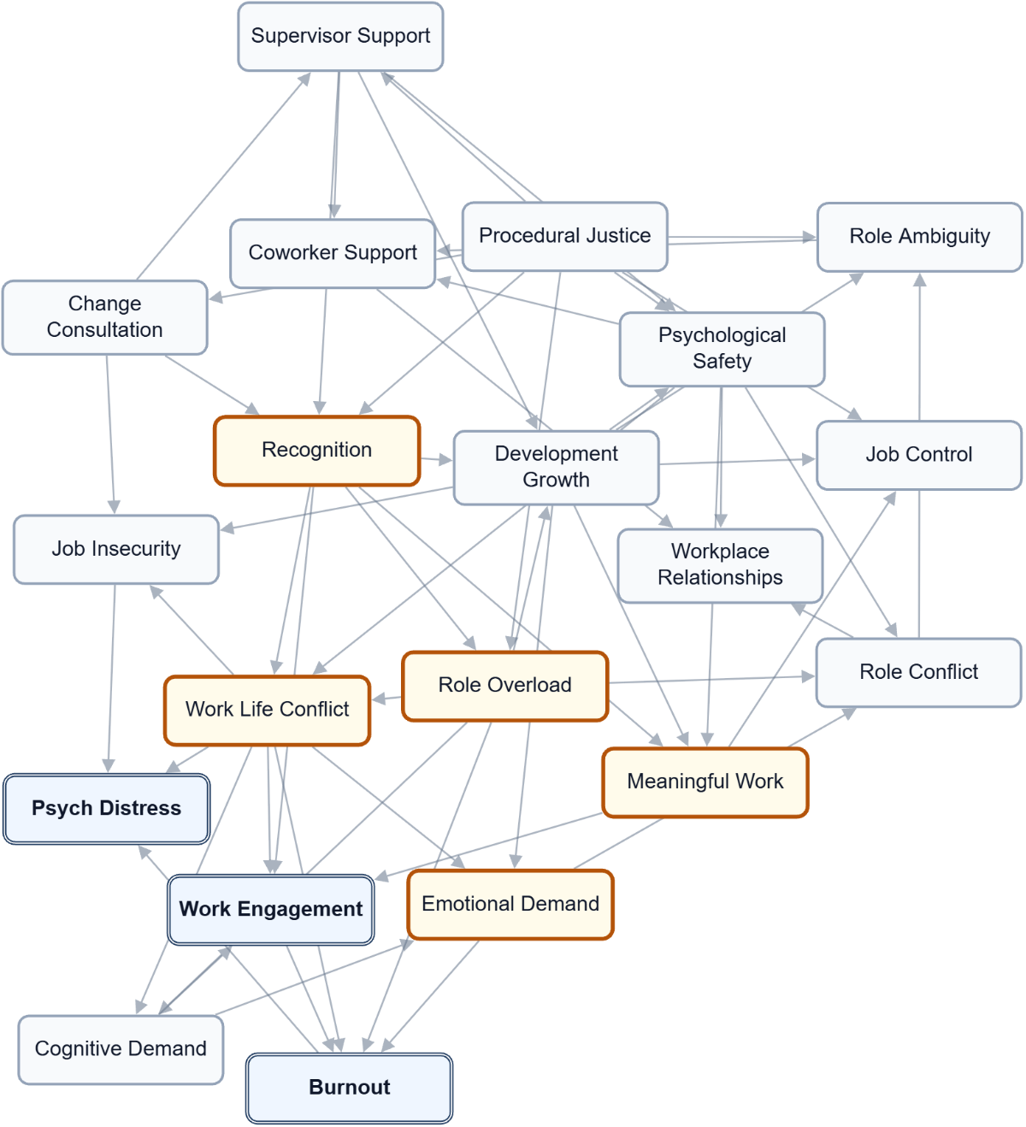

A2 – Starting Model Estimates
Starting probabilities from the report model, before a scenario is applied. These are model estimates, not raw response counts. State labels and any recorded direction are shown for each factor. Not applicable means the factor does not use that state; unavailable means its probability was not supplied.
Factor | Low (L) | Moderate (M) | High (H) | Recorded direction
Burnout | 33.3% | 41.1% | 25.5% | Lower is favourable
Change Consultation | 28.4% | 43.7% | 27.9% | Higher is favourable
Cognitive Demand | 12.5% | 45.2% | 42.3% | Lower is favourable
Coworker Support | 15.7% | 42.0% | 42.2% | Higher is favourable
Development Growth | 14.1% | 37.8% | 48.1% | Higher is favourable
Emotional Demand | 45.3% | 33.1% | 21.6% | Lower is favourable
Job Control | 24.3% | 48.0% | 27.7% | Higher is favourable
Job Insecurity | 55.8% | 28.9% | 15.4% | Lower is favourable
Meaningful Work | 14.5% | 30.6% | 54.9% | Higher is favourable
Procedural Justice | 17.0% | 39.5% | 43.5% | Higher is favourable
Psych Distress | 45.4% | 36.2% | 18.4% | Lower is favourable
Psychological Safety | 11.5% | 38.6% | 49.9% | Higher is favourable
Recognition | 16.8% | 33.3% | 49.9% | Higher is favourable
Role Ambiguity | 66.0% | 28.7% | 5.3% | Lower is favourable
Role Conflict | 41.1% | 36.8% | 22.1% | Lower is favourable
Role Overload | 27.9% | 46.9% | 25.2% | Lower is favourable
Supervisor Support | 20.8% | 36.9% | 42.4% | Higher is favourable
Work Engagement | 18.5% | 47.4% | 34.1% | Higher is favourable
Work Life Conflict | 45.5% | 34.3% | 20.2% | Lower is favourable
Workplace Relationships | 11.1% | 32.1% | 56.8% | Higher is favourable

A3 – Simple Scenarios: One Factor at a Time
Each row compares a hypothetical change in one workplace factor with the starting model. Related conditions can change in the calculation; they are not all held fixed. The exact comparison state is shown where recorded. Positive values increase the named outcome state, which is favourable only where stated. The summed score adds changes across outcomes and is not a share of workers. Do not add separate rows to predict a joint effect.
Factor / scenario state | Work Engagement  H (favourable)  Change (pp) | Burnout  L (favourable)  Change (pp) | Psych Distress  L (favourable)  Change (pp) | Sum (points)
Role Overload  Scenario state: L | -1.1 pp | +19.2 pp | +10.9 pp | +29.0 points
Work Life Conflict  Scenario state: L | +6.5 pp | +9.2 pp | +12.1 pp | +27.8 points
Recognition  Scenario state: H | +10.8 pp | +5.5 pp | +3.6 pp | +19.9 points
Meaningful Work  Scenario state: H | +12.0 pp | +4.2 pp | +1.7 pp | +17.9 points
Procedural Justice  Scenario state: H | +5.8 pp | +4.5 pp | +3.4 pp | +13.8 points
Emotional Demand  Scenario state: L | +0.0 pp | +7.9 pp | +3.5 pp | +11.4 points
Supervisor Support  Scenario state: H | +5.5 pp | +2.6 pp | +2.0 pp | +10.1 points
Psychological Safety  Scenario state: H | +3.2 pp | +1.9 pp | +1.7 pp | +6.8 points
Change Consultation  Scenario state: H | +3.1 pp | +1.5 pp | +2.2 pp | +6.7 points
Development Growth  Scenario state: H | +3.8 pp | +0.5 pp | +1.0 pp | +5.4 points
Job Insecurity  Scenario state: L | +0.0 pp | +0.0 pp | +4.3 pp | +4.3 points
Coworker Support  Scenario state: H | +0.0 pp | +0.0 pp | +0.0 pp | +0.0 points
Job Control  Scenario state: H | +0.0 pp | +0.0 pp | +0.0 pp | +0.0 points
Role Ambiguity  Scenario state: L | +0.0 pp | +0.0 pp | +0.0 pp | +0.0 points
Role Conflict  Scenario state: L | +0.0 pp | +0.0 pp | +0.0 pp | +0.0 points
Workplace Relationships  Scenario state: H | +0.0 pp | +0.0 pp | +0.0 pp | +0.0 points
Cognitive Demand  Scenario state: L | -18.4 pp | -4.3 pp | -1.5 pp | -24.3 points

A4 – Combined Scenarios: Factors Moved Together
These scenarios compare several changes together with the starting model. Their joint effect may be larger or smaller than the sum of separate comparisons. The calculation alone does not establish why, how quickly benefits would appear, or whether an action is feasible. Read each outcome separately.

Top combined scenarios: Work Engagement
H (favourable). Up to five supplied combinations, ranked by this outcome's change rather than the summed score. This is not an exhaustive search of all possible changes.
Factors compared together | Starting share | Scenario share | Change (pp)
Work Life Conflict (L) + Recognition (H) + Meaningful Work (H) | 34.1% | 64.0% | +29.8 pp
Work Life Conflict (L) + Procedural Justice (H) + Meaningful Work (H) | 34.1% | 58.1% | +24.0 pp
Recognition (H) + Meaningful Work (H) + Psychological Safety (H) | 34.1% | 58.0% | +23.9 pp
Work Life Conflict (L) + Supervisor Support (H) + Meaningful Work (H) | 34.1% | 57.8% | +23.6 pp
Supervisor Support (H) + Recognition (H) + Meaningful Work (H) | 34.1% | 57.5% | +23.3 pp

Top combined scenarios: Burnout
L (favourable). Up to five supplied combinations, ranked by this outcome's change rather than the summed score. This is not an exhaustive search of all possible changes.
Factors compared together | Starting share | Scenario share | Change (pp)
Role Overload (L) + Emotional Demand (L) + Meaningful Work (H) | 33.3% | 66.1% | +32.7 pp
Role Overload (L) + Emotional Demand (L) + Recognition (H) | 33.3% | 65.5% | +32.1 pp
Role Overload (L) + Emotional Demand (L) + Work Life Conflict (L) | 33.3% | 64.9% | +31.6 pp
Role Overload (L) + Work Life Conflict (L) + Meaningful Work (H) | 33.3% | 64.2% | +30.8 pp
Role Overload (L) + Emotional Demand (L) + Procedural Justice (H) | 33.3% | 63.3% | +30.0 pp

Top combined scenarios: Psych Distress
L (favourable). Up to five supplied combinations, ranked by this outcome's change rather than the summed score. This is not an exhaustive search of all possible changes.
Factors compared together | Starting share | Scenario share | Change (pp)
Role Overload (L) + Work Life Conflict (L) + Job Insecurity (L) | 45.4% | 66.8% | +21.4 pp
Role Overload (L) + Emotional Demand (L) + Work Life Conflict (L) | 45.4% | 64.9% | +19.5 pp
Role Overload (L) + Work Life Conflict (L) + Meaningful Work (H) | 45.4% | 64.8% | +19.4 pp
Role Overload (L) + Work Life Conflict (L) + Change Consultation (H) | 45.4% | 64.6% | +19.2 pp
Role Overload (L) + Work Life Conflict (L) + Recognition (H) | 45.4% | 64.5% | +19.0 pp

A5 – Methodology and How to Read These Tables
These are estimates from the supplied model. No response-fitting record is available in this export. A sector label alone does not establish a survey source or representative sector observations. The recorded information does not establish a measured baseline for this workplace.
Factors use the state labels recorded in the supplied model; they need not all use the same scale. Scenarios are hypothetical planning comparisons, not promises of achievable change or proof of causation. Changing one factor can also change related factors. Percentages describe the selected state; percentage points describe differences. A summed outcome score is a comparison score, not a percentage of workers.
Numerical uncertainty ranges are not available. Consider answer coverage, the model's source and worker consultation when deciding what to do. Use Data Analytics to explore other factors and scenarios.
Displayed values are rounded. Complete distributions may not total exactly 100%, and changes or summed scores may differ slightly from calculations using the displayed figures.

