Psychosocial Risk Management Report
Test Org

Outcome measures: Work Engagement · Burnout · Psych Distress
Organisation size: 1,200
Date: 25/09/2026
Prepared by: Pat Egan

Generated with Prior Work · priorwork.au · © 2026 Prior Work. Released under CC BY-NC-SA 4.0.

Contents

Executive Summary
Context and Approach
Findings and What They Mean
Starting position and decision focus
Reduce excessive demands without losing valued work
Preserve and strengthen positive features of work
Address emotional demands where they occur
Combined comparisons help clarify priorities
Recommended Next Steps
1. Establish local evidence and clear ownership
2. Protect workers promptly where harm is already known
3. Co-design a small number of practical work changes
4. Review working conditions and outcomes against the local baseline
Appendix – Supporting Material
A1 – How the Factors Connect
A2 – Starting Model Estimates
A3 – Simple Scenarios: One Factor at a Time
A4 – Combined Scenarios: Factors Moved Together
A5 – Methodology and How to Read These Tables

Entries are clickable. For page numbers, right-click the list and choose Update Field.

Executive Summary
Test Org’s senior leaders should establish local evidence, act promptly on confirmed harm and test a small number of work-design improvements for its 1,200 workers.
The evidence comes from the supplied General Australian Workforce model, with an unrecorded data source, no recorded fit to Test Org responses and no available prediction checks. Scenarios assume all workers experience the specified conditions. They are not local workforce findings or forecasts of control effects.
The five focused comparisons suggest:
- Low Role Overload gives the largest reduction in high Burnout, about 15 percentage points, but includes a small engagement trade-off.
- Low Work Life Conflict reduces high Burnout by about 9 points and high Psych Distress by about 8 points, while high Work Engagement gains about 7 points.
- High Meaningful Work and high Recognition produce engagement gains of about 12 and 11 points respectively, alongside smaller adverse-outcome reductions.
- Low Emotional Demand reduces high Burnout by about 9 points, without an estimated engagement change.
Senior leaders should appoint an accountable sponsor, check existing initiatives and create a documented local baseline. Consultation should establish which work arrangements need changing and which strengths should be preserved.
Confirmed harmful demands warrant prompt protection while longer-term changes are developed. Workload and scheduling changes should not transfer problems to other workers or remove useful supports. Review progress against the local baseline using working-condition measures and all three outcomes, rather than engagement alone.

Context and Approach
This report, dated 25 September 2026, helps Test Org’s senior leaders choose priorities for reducing work-related psychological harm and improving working conditions for its 1,200 workers. It is a starting point focused on the workplace factors most useful for the next decision. Other factors can be explored in Data Analytics at priorwork.au.
The evidence comes from the supplied General Australian Workforce model. Its data source and the extent to which worker responses informed it are unrecorded. The name does not establish that it represents Australian workers or contains Test Org responses. Prediction checking and uncertainty ranges are unavailable, so local accuracy is unknown and small numerical differences should not be treated as firm rankings.
Percentages describe model estimates, not direct worker responses. The model’s starting position is not a measured baseline for Test Org. Each scenario estimates hypothetical outcomes if all workers in the modelled population experienced the specified conditions. These comparisons are neither accounts of workers’ current experiences nor predictions of what a proposed control would achieve. Differences between percentages are reported in percentage points.
High Work Engagement is favourable. High Burnout and high Psych Distress are adverse, while their low categories are favourable. These categories describe modelled levels, not clinical diagnoses or the risk of developing an illness. This report concerns working conditions and does not establish legal compliance.
No information about existing initiatives, resource limits or risk register entries was supplied. These need checking before new work is commissioned, to avoid duplication or loss of useful supports.
The supplied Data Analytics > Diagnostics comparison works backwards from low Work Engagement to estimate which working conditions are more or less likely than in the model’s starting position. It helps choose investigation and consultation questions; it does not identify causes, individual experiences, changes over time or the best controls.
If a default Word export is completed, its model overview and interpretation note provide supporting context. Detailed tables are optional, and controls are a separate worksheet.

Findings and What They Mean

Starting position and decision focus
The model’s starting estimates are about 26% for high Burnout, 18% for high Psych Distress and 34% for high Work Engagement.
Burnout covers exhaustion and detachment after prolonged work-related stress. Psych Distress includes anxiety, hopelessness and low mood. Work Engagement describes energy, dedication and absorption in work. Considering all three helps avoid a narrow plan that improves enthusiasm while overlooking harmful working conditions.

Reduce excessive demands without losing valued work
Role Overload means the amount, pace or time pressure of work exceeds what a worker can reasonably manage. Its low scenario produces the largest reduction in high Burnout among the five focused single-factor comparisons: about 15 percentage points, to about 10%. High Psych Distress reduces by about 7 points, to about 11%.
There is a small engagement trade-off. High Work Engagement is about 1 percentage point lower, while low Work Engagement is about 2 points higher. This is not a reason to retain excessive demands. It makes engagement worth monitoring while work is redesigned, including whether valued tasks are being removed along with unnecessary work.
Work Life Conflict concerns work interfering with home life, relationships or other responsibilities. In its low scenario, high Burnout reduces by about 9 percentage points and high Psych Distress by about 8 points. High Work Engagement also gains about 7 points.
This gives work–home interference a place alongside workload volume in local investigation. Consultation should establish whether interference concerns total workload, unpredictable hours, contact outside agreed hours or another feature of work. The answer matters: better schedule notice will not resolve a workload that still requires regular unpaid or extended work.
A related caution is to avoid removing all mental challenge. The low Cognitive Demand scenario loses about 18 percentage points of high Work Engagement, 4 points of low Burnout and 1.5 points of low Psych Distress. These are losses in favourable categories. This supports distinguishing excessive workload from useful, manageable challenge, rather than making all work less demanding.

Preserve and strengthen positive features of work
The model’s starting position includes high Meaningful Work at about 55% and high Recognition at about 50%. These favourable modelled conditions give equal reason to ask what should be preserved, not just what needs fixing.
Meaningful Work describes work that feels purposeful and worthwhile, uses workers’ strengths and makes their contribution clear. Its high scenario gives the largest engagement gain among the five focused comparisons: about 12 percentage points, taking high Work Engagement to about 46%. High Burnout also reduces by about 4 points and high Psych Distress by about 1 point.
The practical opportunity is to identify which parts of work workers value before redesigning tasks. Removing duplication may free time for worthwhile work, but removing valued responsibilities could have a different result. Consultation should distinguish those possibilities rather than assume that fewer tasks always means better work.
In the high Recognition scenario, high Work Engagement gains about 11 percentage points, to about 45%. High Burnout reduces by about 5 points and high Psych Distress by about 3 points.
Recognition includes feedback and acknowledgement, but also fair pay and opportunities to progress. Local consultation should establish which aspect matters. A gap in timely feedback may be addressed by managers; concerns about pay or progression may require decisions from senior leaders. Recognition should complement, not replace, action on confirmed excessive demands.

Address emotional demands where they occur
In the low Emotional Demand scenario, high Burnout reduces by about 9 percentage points and high Psych Distress by about 3 points. There is no estimated change in high Work Engagement.
Emotional Demand includes responding to others’ distress and managing the emotions shown at work. Its results support targeted investigation of roles and situations involving these demands. Engagement alone would be an incomplete check on whether such work is safe and manageable.
Where demanding interactions are inherent to the role, practical options may include reducing avoidable exposure, ensuring help is available during difficult situations, and providing covered recovery time. These are possibilities to examine locally, not established explanations for conditions at Test Org.

Combined comparisons help clarify priorities
Two supplied combinations illustrate the balance between reducing adverse outcomes and strengthening engagement. They are alternative comparisons, not mutually exclusive action plans.
The table shows rounded percentage-point changes from the model’s starting position.
Conditions experienced in the scenario | Reduction in high Burnout | Reduction in high Psych Distress | Gain in high Work Engagement
A: Low Role Overload, low Work Life Conflict and high Meaningful Work | 20 | 12 | 15
B: Low Work Life Conflict, high Recognition and high Meaningful Work | 15 | 10 | 30

Scenario A estimates larger reductions in the adverse categories. Scenario B estimates a larger engagement gain. For leaders, this means the choice of work to investigate and resource first should reflect locally established harm as well as positive-work opportunities. A larger engagement gain is not a reason to leave confirmed overload unaddressed.
The supplied joint assessment also cautions against adding separate gains. In Scenario A, gains in high Work Engagement, low Burnout and low Psych Distress overlap: the combined gains are smaller than the sum of the separate gains. In Scenario B, the engagement gain is close to the sum of the separate gains, while gains in the other two favourable categories overlap. The table therefore uses the supplied combined estimates.

Recommended Next Steps

1. Establish local evidence and clear ownership
Senior leaders should appoint an executive sponsor and a coordinating lead, supported by those responsible for operations, work health and safety, and people management. Workers and their representatives should help identify problems and shape workable changes.
The first task is to check current initiatives, existing controls, planned changes and available resources. Suitable existing work should be strengthened rather than replaced by a parallel programme. Leaders should also make clear who can approve changes to priorities, staffing, schedules, pay or progression.
Establish a first documented local baseline for this plan, drawing on any suitable existing evidence to avoid duplication. Use confidential assessment and consultation across relevant roles and work patterns. Record:
- The questions, outcome categories, assessment date and participation.
- Workers’ experiences of the five focused conditions and all three outcomes.
- Relevant work information, such as demand volumes, unplanned overtime, schedule changes or missed breaks.
- Existing arrangements that workers find useful and want retained.
This assessment should establish where concerns occur, how serious they are and which work arrangements can be changed. It should not use the model’s starting percentages as Test Org’s measured baseline.

2. Protect workers promptly where harm is already known
Locally established harmful conditions should not wait for the assessment or a longer-term redesign programme. Responsible managers should take prompt protective action within their authority and escalate resource or service decisions they cannot resolve.
Depending on the issue, temporary options may include deferring lower-priority work, changing deadlines, providing additional coverage, protecting breaks or clarifying how to obtain help during demanding interactions. Appropriate confidential support can sit alongside these changes, not replace them.
Before reallocating work, check what will happen to the receiving workers’ workload and support. A change that merely moves excessive demands to another team has not resolved the problem. Temporary arrangements should have an owner and frequent review while a sustainable solution is developed.

3. Co-design a small number of practical work changes
The following are suggestions for consultation and testing, not findings about local causes. Selection should depend on the local assessment, available authority and resources.
Focus | What consultation should establish | Suggested decision and responsible role
Role Overload | Which tasks, deadlines or demand peaks make work unmanageable? What could stop, change or receive more time without moving the problem elsewhere? | Operational leaders could remove duplication, agree priorities or change deadlines. If essential demand still exceeds capacity, senior leaders should decide on resources or service expectations rather than relying on workers to work faster.
Work Life Conflict | Does interference mainly concern unpredictable schedules, extended hours, contact expectations or work that follows workers home? Which arrangements already help? | Scheduling and operational leaders could test better notice, clearer availability boundaries or improved coverage. Where workload is the issue, these changes need to be paired with workload decisions.
Meaningful Work | Which tasks feel worthwhile and use workers’ strengths? Would proposed task removal also remove valued work? | Operational leaders could preserve valued tasks when removing unnecessary work and make the purpose of necessary tasks clearer. Improvements should fit within available work time, not add responsibilities without capacity.
Recognition | Is the main gap useful feedback, acknowledgement, fair pay or access to progression? What do workers consider fair and credible? | Managers could improve timely, specific feedback. Leaders with pay and progression authority should examine concerns in those areas rather than treating praise as a substitute.
Emotional Demand | Where do demanding interactions occur, which exposures are avoidable, and can workers obtain help and recovery time when needed? | Operational leaders could review exposure, escalation arrangements and covered recovery time. Any rotation or redistribution should account for the skills, preparation and workload of receiving workers.

For each selected change, leaders should approve an owner, the time and resources required, the work it will displace and a review date. Existing valued supports should be retained unless there is a clear reason to change them.

4. Review working conditions and outcomes against the local baseline
Progress checks should ask both whether the agreed change happened and whether workers’ experiences improved. For example, a new contact rule is not enough if workers still feel expected to respond outside agreed hours.
Protective measures may need frequent review. As a planning guide, an early implementation check at around four to six weeks and a repeat pulse at around three months could support longer-term improvements. Timing should be adjusted to the seriousness of the concern and the nature of the change.
Follow-up should use consistent questions and category definitions, retain the recorded local baseline, and note participation and changes in who responded. Track high Burnout and high Psych Distress directly, alongside high and low Work Engagement and the five working conditions.
Leaders should also check for displaced workload, lost support or loss of valued work. Continue, adjust or expand changes using worker feedback and work information together. A better engagement result should not offset worsening exhaustion or distress. Before-and-after differences support review, but do not by themselves establish what caused a change.

Appendix – Supporting Material

A1 – How the Factors Connect
This overview includes every modelled factor and connection. Connections show analytical assumptions, not established causes or relationship strength. Read it alongside the source note below.
Complete model snapshot. Double blue borders identify outcomes; amber borders identify the selected report priorities. All recorded connections are shown. Positions and line widths do not rank importance. Connections show the direction used in the analysis, not proof of causation.
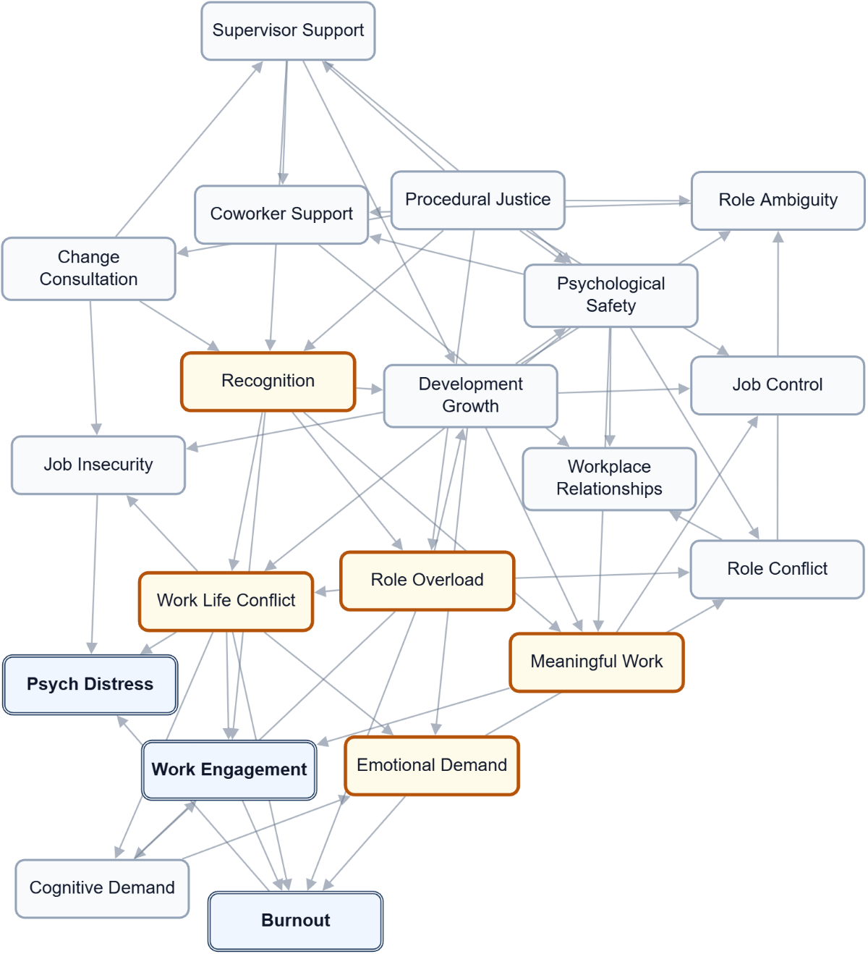

A2 – Starting Model Estimates
Starting probabilities from the report model, before a scenario is applied. These are model estimates, not raw response counts. State labels and any recorded direction are shown for each factor. Not applicable means the factor does not use that state; unavailable means its probability was not supplied.
Factor | Low (L) | Moderate (M) | High (H) | Recorded direction
Burnout | 33.3% | 41.1% | 25.5% | Lower is favourable
Change Consultation | 28.4% | 43.7% | 27.9% | Higher is favourable
Cognitive Demand | 12.5% | 45.2% | 42.3% | Lower is favourable
Coworker Support | 15.7% | 42.0% | 42.2% | Higher is favourable
Development Growth | 14.1% | 37.8% | 48.1% | Higher is favourable
Emotional Demand | 45.3% | 33.1% | 21.6% | Lower is favourable
Job Control | 24.3% | 48.0% | 27.7% | Higher is favourable
Job Insecurity | 55.8% | 28.9% | 15.4% | Lower is favourable
Meaningful Work | 14.5% | 30.6% | 54.9% | Higher is favourable
Procedural Justice | 17.0% | 39.5% | 43.5% | Higher is favourable
Psych Distress | 45.4% | 36.2% | 18.4% | Lower is favourable
Psychological Safety | 11.5% | 38.6% | 49.9% | Higher is favourable
Recognition | 16.8% | 33.3% | 49.9% | Higher is favourable
Role Ambiguity | 66.0% | 28.7% | 5.3% | Lower is favourable
Role Conflict | 41.1% | 36.8% | 22.1% | Lower is favourable
Role Overload | 27.9% | 46.9% | 25.2% | Lower is favourable
Supervisor Support | 20.8% | 36.9% | 42.4% | Higher is favourable
Work Engagement | 18.5% | 47.4% | 34.1% | Higher is favourable
Work Life Conflict | 45.5% | 34.3% | 20.2% | Lower is favourable
Workplace Relationships | 11.1% | 32.1% | 56.8% | Higher is favourable

A3 – Simple Scenarios: One Factor at a Time
Each row compares a hypothetical change in one workplace factor with the starting model. Related conditions can change in the calculation; they are not all held fixed. The exact comparison state is shown where recorded. Positive values increase the named outcome state, which is favourable only where stated. The summed score adds changes across outcomes and is not a share of workers. Do not add separate rows to predict a joint effect.
Factor / scenario state | Work Engagement  H (favourable)  Change (pp) | Burnout  L (favourable)  Change (pp) | Psych Distress  L (favourable)  Change (pp) | Sum (points)
Role Overload  Scenario state: L | -1.1 pp | +19.2 pp | +10.9 pp | +29.0 points
Work Life Conflict  Scenario state: L | +6.5 pp | +9.2 pp | +12.1 pp | +27.8 points
Recognition  Scenario state: H | +10.8 pp | +5.5 pp | +3.6 pp | +19.9 points
Meaningful Work  Scenario state: H | +12.0 pp | +4.2 pp | +1.7 pp | +17.9 points
Procedural Justice  Scenario state: H | +5.8 pp | +4.5 pp | +3.4 pp | +13.8 points
Emotional Demand  Scenario state: L | +0.0 pp | +7.9 pp | +3.5 pp | +11.4 points
Supervisor Support  Scenario state: H | +5.5 pp | +2.6 pp | +2.0 pp | +10.1 points
Psychological Safety  Scenario state: H | +3.2 pp | +1.9 pp | +1.7 pp | +6.8 points
Change Consultation  Scenario state: H | +3.1 pp | +1.5 pp | +2.2 pp | +6.7 points
Development Growth  Scenario state: H | +3.8 pp | +0.5 pp | +1.0 pp | +5.4 points
Job Insecurity  Scenario state: L | +0.0 pp | +0.0 pp | +4.3 pp | +4.3 points
Coworker Support  Scenario state: H | +0.0 pp | +0.0 pp | +0.0 pp | +0.0 points
Job Control  Scenario state: H | +0.0 pp | +0.0 pp | +0.0 pp | +0.0 points
Role Ambiguity  Scenario state: L | +0.0 pp | +0.0 pp | +0.0 pp | +0.0 points
Role Conflict  Scenario state: L | +0.0 pp | +0.0 pp | +0.0 pp | +0.0 points
Workplace Relationships  Scenario state: H | +0.0 pp | +0.0 pp | +0.0 pp | +0.0 points
Cognitive Demand  Scenario state: L | -18.4 pp | -4.3 pp | -1.5 pp | -24.3 points

A4 – Combined Scenarios: Factors Moved Together
These scenarios compare several changes together with the starting model. Their joint effect may be larger or smaller than the sum of separate comparisons. The calculation alone does not establish why, how quickly benefits would appear, or whether an action is feasible. Read each outcome separately.

Top combined scenarios: Work Engagement
H (favourable). Up to five supplied combinations, ranked by this outcome's change rather than the summed score. This is not an exhaustive search of all possible changes.
Factors compared together | Starting share | Scenario share | Change (pp)
Work Life Conflict (L) + Recognition (H) + Meaningful Work (H) | 34.1% | 64.0% | +29.8 pp
Work Life Conflict (L) + Procedural Justice (H) + Meaningful Work (H) | 34.1% | 58.1% | +24.0 pp
Recognition (H) + Meaningful Work (H) + Psychological Safety (H) | 34.1% | 58.0% | +23.9 pp
Work Life Conflict (L) + Supervisor Support (H) + Meaningful Work (H) | 34.1% | 57.8% | +23.6 pp
Supervisor Support (H) + Recognition (H) + Meaningful Work (H) | 34.1% | 57.5% | +23.3 pp

Top combined scenarios: Burnout
L (favourable). Up to five supplied combinations, ranked by this outcome's change rather than the summed score. This is not an exhaustive search of all possible changes.
Factors compared together | Starting share | Scenario share | Change (pp)
Role Overload (L) + Emotional Demand (L) + Meaningful Work (H) | 33.3% | 66.1% | +32.7 pp
Role Overload (L) + Emotional Demand (L) + Recognition (H) | 33.3% | 65.5% | +32.1 pp
Role Overload (L) + Emotional Demand (L) + Work Life Conflict (L) | 33.3% | 64.9% | +31.6 pp
Role Overload (L) + Work Life Conflict (L) + Meaningful Work (H) | 33.3% | 64.2% | +30.8 pp
Role Overload (L) + Emotional Demand (L) + Procedural Justice (H) | 33.3% | 63.3% | +30.0 pp

Top combined scenarios: Psych Distress
L (favourable). Up to five supplied combinations, ranked by this outcome's change rather than the summed score. This is not an exhaustive search of all possible changes.
Factors compared together | Starting share | Scenario share | Change (pp)
Role Overload (L) + Work Life Conflict (L) + Job Insecurity (L) | 45.4% | 66.8% | +21.4 pp
Role Overload (L) + Emotional Demand (L) + Work Life Conflict (L) | 45.4% | 64.9% | +19.5 pp
Role Overload (L) + Work Life Conflict (L) + Meaningful Work (H) | 45.4% | 64.8% | +19.4 pp
Role Overload (L) + Work Life Conflict (L) + Change Consultation (H) | 45.4% | 64.6% | +19.2 pp
Role Overload (L) + Work Life Conflict (L) + Recognition (H) | 45.4% | 64.5% | +19.0 pp

A5 – Methodology and How to Read These Tables
These are estimates from the supplied model. No response-fitting record is available in this export. A sector label alone does not establish a survey source or representative sector observations. The recorded information does not establish a measured baseline for this workplace.
Factors use the state labels recorded in the supplied model; they need not all use the same scale. Scenarios are hypothetical planning comparisons, not promises of achievable change or proof of causation. Changing one factor can also change related factors. Percentages describe the selected state; percentage points describe differences. A summed outcome score is a comparison score, not a percentage of workers.
Numerical uncertainty ranges are not available. Consider answer coverage, the model's source and worker consultation when deciding what to do. Use Data Analytics to explore other factors and scenarios.
Displayed values are rounded. Complete distributions may not total exactly 100%, and changes or summed scores may differ slightly from calculations using the displayed figures.

