Psychosocial Risk Management Report
Test Org

Outcome measures: Work Engagement · Burnout · Psych Distress
Organisation size: 1,200
Date: 25/09/2026
Prepared by: Pat Egan

Generated with Prior Work · priorwork.au · © 2026 Prior Work. Released under CC BY-NC-SA 4.0.

Contents

Executive Summary
Context and Approach
Findings and What They Mean
The starting position
Role Overload: the largest lever on Burnout, with a trade-off
Work Life Conflict: consistent gains across all three outcomes
Recognition and Meaningful Work: the main levers on Work Engagement
Emotional Demand: a Burnout risk to examine at role and team level
Combined comparisons: resolving the trade-off
What Diagnostics suggests asking
A caution outside the focus
Recommended Next Steps
1. Conduct a first local assessment (executive sponsor; people and safety leads)
2. Act promptly where excessive demand is locally established (operational managers)
3. Identify emotionally demanding roles and confirm supports (people lead with relevant managers)
4. Protect Recognition and Meaningful Work through change (executive team)
5. Develop a combined program rather than a workload program alone (executive team)
6. Check progress against the recorded baseline (people and safety leads; executive review)
Appendix – Supporting Material
A1 – How the Factors Connect
A2 – Starting Model Estimates
A3 – Simple Scenarios: One Factor at a Time
A4 – Combined Scenarios: Factors Moved Together
A5 – Methodology and How to Read These Tables

Entries are clickable. For page numbers, right-click the list and choose Update Field.

Executive Summary
Test Org, with about 1,200 workers, commissioned this report to guide decisions on psychosocial risk and opportunity across three outcomes: Work Engagement, Burnout and Psych Distress. The evidence is a General Australian Workforce model with no record of fitting to Test Org's own responses and no prediction check, so its figures are expectations to be tested locally, not measurements of this workforce. Comparisons assume every worker experienced a given condition.
The model estimates about 26% of workers in the high Burnout category, about 18% in high Psych Distress and only about 34% in high Work Engagement. Five factors were selected as most useful. Low Role Overload is the largest lever on Burnout, reducing the high category by about 15 percentage points, but on its own slightly lowers engagement. Low Work Life Conflict improves all three outcomes, reducing high Burnout and high Psych Distress by about 9 and 8 points and lifting high engagement by about 7 points. Recognition and Meaningful Work are estimated strengths and the main drivers of engagement; losing them would cut high engagement to around 16% and 9% respectively. Emotional Demand is a Burnout risk that is best examined at role and team level in a first local assessment. Combining low Role Overload with high Recognition and Meaningful Work removes the trade-off, with high Burnout falling to about 6% and high engagement rising to about 56%.
The next decisions are to commission a first local assessment to establish a baseline, act promptly where excessive demand is found, protect recognition and meaning through change, and build a combined program rather than a workload program alone. Other factors can be explored in Data Analytics at priorwork.au.

Context and Approach
Test Org, an organisation of about 1,200 workers, commissioned this report to help its senior leaders decide where to direct attention and resources in managing psychosocial risks and opportunities at work. The report focuses on three outcomes: Work Engagement (feeling energetic, dedicated and absorbed in work), Burnout (exhaustion and detachment after prolonged work-related stress) and Psych Distress (anxiety, hopelessness or low mood). It examines five workplace factors selected as the most useful for the next decision: Role Overload, Work Life Conflict, Recognition, Meaningful Work and Emotional Demand. It is a starting point, not a complete account; other factors remain available to explore in Data Analytics at priorwork.au.
The evidence comes from a model labelled General Australian Workforce. Its source is unrecorded: there is no record of it being fitted to Test Org's own worker responses, no recorded observation count, and no prediction check on its accuracy. The sector label does not, on its own, establish that the figures describe Test Org, and the estimates are point estimates with no uncertainty ranges. The findings should therefore be read as a structured set of expectations about how working conditions and outcomes tend to relate, to be tested locally, rather than as a measurement of this workforce. No local baseline or earlier assessment is recorded, and no existing initiatives or risk register entries were supplied.
Each factor and outcome is described in three categories: high (H), medium (M) and low (L). The model estimates the share of workers likely to fall in each category. For Burnout and Psych Distress, the high category is the adverse one; for Work Engagement, the high category is the favourable one. Modelled comparisons ask a hypothetical question: if every worker experienced a specified level of a factor, how would the share in each outcome category change compared with the starting position? These whole-population comparisons are not predictions of what a particular program would achieve, because no real change moves everyone at once. Differences are reported in percentage points.
Data Analytics also includes a Diagnostics view that works in the opposite direction. Instead of changing a factor and reading off the outcome, it starts from an outcome of concern, such as low Work Engagement, and estimates which working conditions are more likely to be present alongside it. This does not establish causes or explain any individual's situation, but it does help to shape consultation and investigation questions.

Findings and What They Mean

The starting position
The model's starting estimates give a sense of scale. About 26% of workers are estimated to sit in the high Burnout category and about 18% in the high Psych Distress category. Only about 34% are estimated to sit in the high Work Engagement category, with about 18% in the low category and the remainder in the middle. Among the five focus factors, about 25% of workers are estimated to experience high Role Overload, about 20% high Work Life Conflict and about 22% high Emotional Demand. On the positive side, about 50% are estimated to experience high Recognition and about 55% high Meaningful Work, with only about 17% and 15% respectively in the low categories. These are general-workforce expectations, and a first local assessment is needed to confirm whether they hold at Test Org.

Role Overload: the largest lever on Burnout, with a trade-off
Role Overload describes the experience that the amount, pace or time pressure of work exceeds what a person can reasonably manage. In the model, it has the strongest single link to Burnout. If every worker experienced low Role Overload, the share in the high Burnout category is estimated to fall from about 26% to about 10%, a reduction of around 15 percentage points. The share in the high Psych Distress category is estimated to fall from about 18% to about 11%, a reduction of around 7 percentage points. The reverse scenario is also informative: if everyone experienced high Role Overload, high Burnout rises to about 46%, an increase of around 20 percentage points.
There is a trade-off to report faithfully. Low Role Overload on its own slightly worsens Work Engagement: the high category falls by about 1.1 percentage points and the low category rises by about 1.8 percentage points. These shifts are small, but they suggest that simply removing pressure does not create enthusiasm for the work. This matters for how workload is managed: reducing excessive demand protects against exhaustion, but engagement depends on other conditions, which the combined comparisons below address.

Work Life Conflict: consistent gains across all three outcomes
Work Life Conflict describes work demands interfering with home life, relationships and other responsibilities. Like Recognition and Meaningful Work, it improves all three outcomes, and among the focus factors it has the most even spread of gains across them. If every worker experienced low Work Life Conflict, high Burnout is estimated to fall from about 26% to about 16% (around 9 percentage points), high Psych Distress from about 18% to about 10% (around 8 percentage points), and high Work Engagement to rise from about 34% to about 41% (around 7 percentage points). Between its best and worst levels, this factor produces the largest total swing across the three outcomes of any factor in the model, and high Work Life Conflict alone raises high Psych Distress to about 33%. In practical terms, the model suggests that hours, rostering, after-hours contact and predictability of work are worth examining as a whole rather than as a workload question alone.

Recognition and Meaningful Work: the main levers on Work Engagement
Recognition covers whether effort and contribution are noticed and acknowledged through feedback, fair pay or opportunities to progress. Meaningful Work covers whether work feels purposeful, uses a person's strengths and shows why their contribution matters. Both are estimated to be strengths in the starting position, with around half or more of workers in the high categories, and both are the strongest links to Work Engagement.
If every worker experienced high Recognition, high Work Engagement is estimated to rise from about 34% to about 45% (around 11 percentage points), with the low category falling by about 8 percentage points. High Burnout falls by about 5 percentage points and high Psych Distress by about 3 percentage points. For Meaningful Work, universal high experience lifts high Work Engagement to about 46% (around 12 percentage points), reduces high Burnout by about 4 percentage points and high Psych Distress by about 1 percentage point.
The downside scenarios are steeper than the gains, which is the more important message for a workforce where these conditions are currently favourable. If everyone experienced low Meaningful Work, high Work Engagement falls to about 9% and the low category rises to about 42%, an increase of around 24 percentage points; high Burnout rises by about 9 percentage points. Low Recognition produces a similar pattern, with high Work Engagement falling to about 16% and high Burnout rising by about 9 percentage points. The practical implication is that these strengths are worth protecting through periods of change, restructure or cost pressure, because losing them costs more than improving them further would gain.

Emotional Demand: a Burnout risk to examine at role and team level
Emotional Demand describes emotionally demanding interactions, such as responding to others' distress or managing the emotions shown as part of a role. It has no estimated effect on Work Engagement, but it matters for Burnout. If every worker experienced low Emotional Demand, high Burnout falls from about 26% to about 16% (around 9 percentage points) and high Psych Distress by about 3 percentage points. If everyone experienced high Emotional Demand, high Burnout rises to about 43%, an increase of around 18 percentage points. The model estimates that about 22% of workers experience high Emotional Demand, but it provides only a workforce-wide figure and no breakdown by role or team. Because emotionally demanding interactions typically vary with the nature of a role, a first local assessment that can report by team or role group is the way to establish whether this demand is concentrated at Test Org, and therefore whether a role-level or a workforce-wide response is appropriate.

Combined comparisons: resolving the trade-off
Because low Role Overload alone slightly reduces Work Engagement, the combined comparisons are useful for the decision. The table below shows the two most relevant combinations, using the adverse category for Burnout and Psych Distress and the favourable category for Work Engagement. All figures assume every worker experienced the stated levels.
Combined scenario | High Work Engagement | High Burnout | High Psych Distress
Starting position | about 34% | about 26% | about 18%
Low Role Overload + high Recognition + high Meaningful Work | about 56% (+22 points) | about 6% (−20 points) | about 9% (−10 points)
Low Work Life Conflict + high Recognition + high Meaningful Work | about 64% (+30 points) | about 11% (−15 points) | about 8% (−10 points)

The first combination has the highest overall score among the combined scenarios supplied to this report and shows that pairing demand reduction with recognition and meaning removes the engagement trade-off entirely. For Work Engagement and Burnout, the model's verdict is that the three factors act largely independently, so their separate contributions add up rather than overlap. For Psych Distress, the comparison hits a probability ceiling and the separate and combined effects cannot be cleanly distinguished. The second combination produces the largest Work Engagement gain of any scenario supplied, with partial overlap on the two adverse outcomes. Neither combination is a forecast of a program's results; they indicate which conditions can be addressed together without their gains cancelling out.
An explicit scenario was also supplied combining high Recognition with low Work Life Conflict. Under that scenario, high Work Engagement rises from about 34% to about 51% (around 17 percentage points), high Burnout falls from about 26% to about 13% (around 12 percentage points) and high Psych Distress falls from about 18% to about 9% (around 9 percentage points). This is a useful middle path for an organisation that wants to act on both engagement and wellbeing without a full workload redesign, although it leaves the larger Role Overload effect on Burnout untouched.

What Diagnostics suggests asking
Working backwards from low Work Engagement, the model estimates that low Meaningful Work is much more likely to be present (rising from about 15% to about 37%), as is low Recognition (about 17% to about 33%) and the high Burnout category (about 26% to about 50%). Role Overload barely changes (about 25% to about 27%). These are associations, not causes. They suggest that if consultation finds pockets of disengagement, the first questions should be about whether people see the point of their work and feel their contribution is noticed, rather than assuming workload is the explanation.

A caution outside the focus
One factor outside the focus warrants a brief note because it could lead to a harmful decision. In the model, low Cognitive Demand – the mental effort of concentration, decisions and complex information – reduces high Work Engagement by about 18 percentage points and slightly worsens Burnout. Reducing excessive workload should not be confused with removing mental challenge from jobs, which the model associates with lower engagement.

Recommended Next Steps
Because the model has not been fitted to Test Org's own responses, the first priority is to establish what conditions actually exist locally. The steps below distinguish prompt protection, where a first assessment finds harmful conditions already present, from longer-term improvement.

1. Conduct a first local assessment (executive sponsor; people and safety leads)
No local baseline exists. A first assessment covering the five focus factors and the three outcomes would confirm or correct the general-workforce estimates and create a recorded baseline for later pulse follow-up. It should be able to report by team or role group: the model supplies only workforce-wide estimates, and because emotionally demanding interactions and workload pressure typically vary by role, reporting at that level is needed to test whether Emotional Demand and Role Overload are concentrated at Test Org or spread across the workforce. Consultation with workers and health and safety representatives should be built into the design. A decision point follows: if local results are close to the model, the priorities below stand; if they differ materially, priorities should be reset in Data Analytics using the fitted results.

2. Act promptly where excessive demand is locally established (operational managers)
Where the assessment identifies teams with sustained high Role Overload or high Work Life Conflict, managers should not wait for the longer-term program. Prompt steps could include reviewing vacancies and backfill, pausing or re-sequencing non-critical work, setting clear expectations about after-hours contact, and checking roster predictability. These are suggestions, not established local causes; consultation should establish which specific pressures workers experience and whether they are seasonal or structural, because the answer determines whether resourcing, scheduling or role design is the right response. Any redistribution of work should be checked for displaced load onto other teams.

3. Identify emotionally demanding roles and confirm supports (people lead with relevant managers)
Consultation should establish which roles involve regular exposure to others' distress or difficult interactions, and what supports currently exist, such as debriefing, rotation, supervision or access to assistance programs. If supports are absent or unused, strengthening them is the likely response; if they exist but demand still registers as high, role design and exposure limits become the question.

4. Protect Recognition and Meaningful Work through change (executive team)
The model estimates these as current strengths whose loss would cost far more than further gains would return. The executive team could adopt a simple test for major decisions, including restructures, system changes and cost programs: does this decision make it harder for workers to see the purpose of their work or to have their contribution acknowledged? Existing recognition and feedback practices should be mapped before any are changed, so that supports are not lost inadvertently.

5. Develop a combined program rather than a workload program alone (executive team)
The combined comparisons suggest that reducing excessive demand delivers most for Burnout and Psych Distress, while recognition and meaning deliver most for Work Engagement, and the two streams add up rather than compete. A longer-term program should pair workload and work-life measures with practices that connect workers to purpose and acknowledge contribution. Resourcing decisions should recognise that workload measures often require money or headcount, while recognition and meaning measures more often require management time and consistency.

6. Check progress against the recorded baseline (people and safety leads; executive review)
Once a baseline exists, a pulse follow-up on the same factors and outcomes at an agreed interval, such as six to twelve months, would show whether local conditions are moving. Progress measures should track working conditions themselves, not only outcomes, because conditions respond first. Results and priority changes can be explored in Data Analytics at priorwork.au. The default Word export includes a model overview and an interpretation note; if detailed supporting tables were selected, they contain the full single-factor and combined scenario figures, and a separate controls worksheet is available for recording chosen measures.

Appendix – Supporting Material

A1 – How the Factors Connect
This overview includes every modelled factor and connection. Connections show analytical assumptions, not established causes or relationship strength. Read it alongside the source note below.
Complete model snapshot. Double blue borders identify outcomes; amber borders identify the selected report priorities. All recorded connections are shown. Positions and line widths do not rank importance. Connections show the direction used in the analysis, not proof of causation.
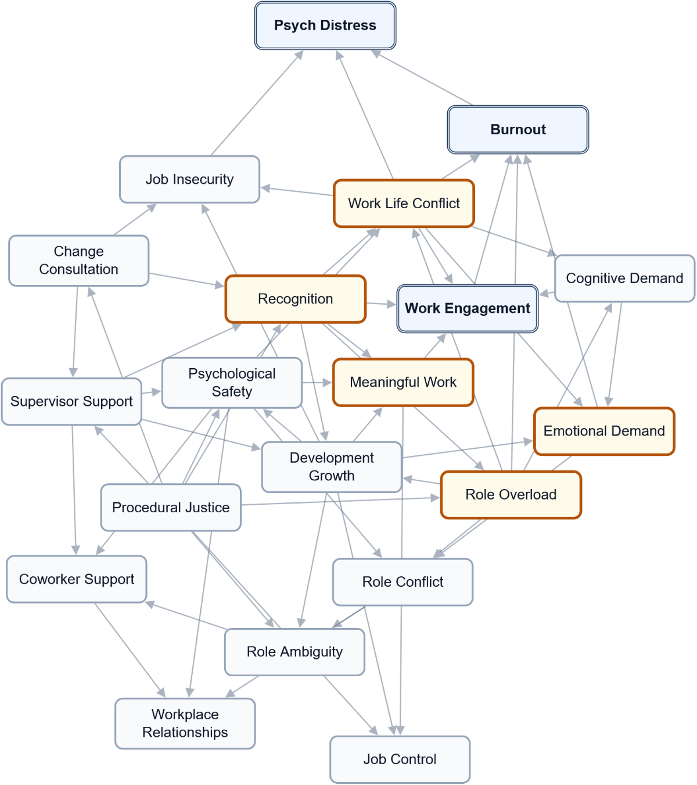

A2 – Starting Model Estimates
Starting probabilities from the report model, before a scenario is applied. These are model estimates, not raw response counts. State labels and any recorded direction are shown for each factor. Not applicable means the factor does not use that state; unavailable means its probability was not supplied.
Factor | Low (L) | Moderate (M) | High (H) | Recorded direction
Burnout | 33.3% | 41.1% | 25.5% | Lower is favourable
Change Consultation | 28.4% | 43.7% | 27.9% | Higher is favourable
Cognitive Demand | 12.5% | 45.2% | 42.3% | Lower is favourable
Coworker Support | 15.7% | 42.0% | 42.2% | Higher is favourable
Development Growth | 14.1% | 37.8% | 48.1% | Higher is favourable
Emotional Demand | 45.3% | 33.1% | 21.6% | Lower is favourable
Job Control | 24.3% | 48.0% | 27.7% | Higher is favourable
Job Insecurity | 55.8% | 28.9% | 15.4% | Lower is favourable
Meaningful Work | 14.5% | 30.6% | 54.9% | Higher is favourable
Procedural Justice | 17.0% | 39.5% | 43.5% | Higher is favourable
Psych Distress | 45.4% | 36.2% | 18.4% | Lower is favourable
Psychological Safety | 11.5% | 38.6% | 49.9% | Higher is favourable
Recognition | 16.8% | 33.3% | 49.9% | Higher is favourable
Role Ambiguity | 66.0% | 28.7% | 5.3% | Lower is favourable
Role Conflict | 41.1% | 36.8% | 22.1% | Lower is favourable
Role Overload | 27.9% | 46.9% | 25.2% | Lower is favourable
Supervisor Support | 20.8% | 36.9% | 42.4% | Higher is favourable
Work Engagement | 18.5% | 47.4% | 34.1% | Higher is favourable
Work Life Conflict | 45.5% | 34.3% | 20.2% | Lower is favourable
Workplace Relationships | 11.1% | 32.1% | 56.8% | Higher is favourable

A3 – Simple Scenarios: One Factor at a Time
Each row compares a hypothetical change in one workplace factor with the starting model. Related conditions can change in the calculation; they are not all held fixed. The exact comparison state is shown where recorded. Positive values increase the named outcome state, which is favourable only where stated. The summed score adds changes across outcomes and is not a share of workers. Do not add separate rows to predict a joint effect.
Factor / scenario state | Work Engagement  H (favourable)  Change (pp) | Burnout  L (favourable)  Change (pp) | Psych Distress  L (favourable)  Change (pp) | Sum (points)
Role Overload  Scenario state: L | -1.1 pp | +19.2 pp | +10.9 pp | +29.0 points
Work Life Conflict  Scenario state: L | +6.5 pp | +9.2 pp | +12.1 pp | +27.8 points
Recognition  Scenario state: H | +10.8 pp | +5.5 pp | +3.6 pp | +19.9 points
Meaningful Work  Scenario state: H | +12.0 pp | +4.2 pp | +1.7 pp | +17.9 points
Procedural Justice  Scenario state: H | +5.8 pp | +4.5 pp | +3.4 pp | +13.8 points
Emotional Demand  Scenario state: L | +0.0 pp | +7.9 pp | +3.5 pp | +11.4 points
Supervisor Support  Scenario state: H | +5.5 pp | +2.6 pp | +2.0 pp | +10.1 points
Psychological Safety  Scenario state: H | +3.2 pp | +1.9 pp | +1.7 pp | +6.8 points
Change Consultation  Scenario state: H | +3.1 pp | +1.5 pp | +2.2 pp | +6.7 points
Development Growth  Scenario state: H | +3.8 pp | +0.5 pp | +1.0 pp | +5.4 points
Job Insecurity  Scenario state: L | +0.0 pp | +0.0 pp | +4.3 pp | +4.3 points
Coworker Support  Scenario state: H | +0.0 pp | +0.0 pp | +0.0 pp | +0.0 points
Job Control  Scenario state: H | +0.0 pp | +0.0 pp | +0.0 pp | +0.0 points
Role Ambiguity  Scenario state: L | +0.0 pp | +0.0 pp | +0.0 pp | +0.0 points
Role Conflict  Scenario state: L | +0.0 pp | +0.0 pp | +0.0 pp | +0.0 points
Workplace Relationships  Scenario state: H | +0.0 pp | +0.0 pp | +0.0 pp | +0.0 points
Cognitive Demand  Scenario state: L | -18.4 pp | -4.3 pp | -1.5 pp | -24.3 points

A4 – Combined Scenarios: Factors Moved Together
These scenarios compare several changes together with the starting model. Their joint effect may be larger or smaller than the sum of separate comparisons. The calculation alone does not establish why, how quickly benefits would appear, or whether an action is feasible. Read each outcome separately.

Top combined scenarios: Work Engagement
H (favourable). Up to five supplied combinations, ranked by this outcome's change rather than the summed score. This is not an exhaustive search of all possible changes.
Factors compared together | Starting share | Scenario share | Change (pp)
Work Life Conflict (L) + Recognition (H) + Meaningful Work (H) | 34.1% | 64.0% | +29.8 pp
Work Life Conflict (L) + Procedural Justice (H) + Meaningful Work (H) | 34.1% | 58.1% | +24.0 pp
Recognition (H) + Meaningful Work (H) + Psychological Safety (H) | 34.1% | 58.0% | +23.9 pp
Work Life Conflict (L) + Supervisor Support (H) + Meaningful Work (H) | 34.1% | 57.8% | +23.6 pp
Supervisor Support (H) + Recognition (H) + Meaningful Work (H) | 34.1% | 57.5% | +23.3 pp

Top combined scenarios: Burnout
L (favourable). Up to five supplied combinations, ranked by this outcome's change rather than the summed score. This is not an exhaustive search of all possible changes.
Factors compared together | Starting share | Scenario share | Change (pp)
Role Overload (L) + Emotional Demand (L) + Meaningful Work (H) | 33.3% | 66.1% | +32.7 pp
Role Overload (L) + Emotional Demand (L) + Recognition (H) | 33.3% | 65.5% | +32.1 pp
Role Overload (L) + Emotional Demand (L) + Work Life Conflict (L) | 33.3% | 64.9% | +31.6 pp
Role Overload (L) + Work Life Conflict (L) + Meaningful Work (H) | 33.3% | 64.2% | +30.8 pp
Role Overload (L) + Emotional Demand (L) + Procedural Justice (H) | 33.3% | 63.3% | +30.0 pp

Top combined scenarios: Psych Distress
L (favourable). Up to five supplied combinations, ranked by this outcome's change rather than the summed score. This is not an exhaustive search of all possible changes.
Factors compared together | Starting share | Scenario share | Change (pp)
Role Overload (L) + Work Life Conflict (L) + Job Insecurity (L) | 45.4% | 66.8% | +21.4 pp
Role Overload (L) + Emotional Demand (L) + Work Life Conflict (L) | 45.4% | 64.9% | +19.5 pp
Role Overload (L) + Work Life Conflict (L) + Meaningful Work (H) | 45.4% | 64.8% | +19.4 pp
Role Overload (L) + Work Life Conflict (L) + Change Consultation (H) | 45.4% | 64.6% | +19.2 pp
Role Overload (L) + Work Life Conflict (L) + Recognition (H) | 45.4% | 64.5% | +19.0 pp

A5 – Methodology and How to Read These Tables
These are estimates from the supplied model. No response-fitting record is available in this export. A sector label alone does not establish a survey source or representative sector observations. The recorded information does not establish a measured baseline for this workplace.
Factors use the state labels recorded in the supplied model; they need not all use the same scale. Scenarios are hypothetical planning comparisons, not promises of achievable change or proof of causation. Changing one factor can also change related factors. Percentages describe the selected state; percentage points describe differences. A summed outcome score is a comparison score, not a percentage of workers.
Numerical uncertainty ranges are not available. Consider answer coverage, the model's source and worker consultation when deciding what to do. Use Data Analytics to explore other factors and scenarios.
Displayed values are rounded. Complete distributions may not total exactly 100%, and changes or summed scores may differ slightly from calculations using the displayed figures.

