Psychosocial Risk Management Report
Test Org

Outcome measures: Work Engagement · Burnout · Psych Distress
Organisation size: 1,200
Date: 25/09/2026
Prepared by: Pat Egan

Generated with Prior Work · priorwork.au · © 2026 Prior Work. Released under CC BY-NC-SA 4.0.

Contents

Executive Summary
Context and Approach
Where the evidence comes from
How to read the outcomes and comparisons
Findings and What They Mean
Where the outcomes start
Workload and work-life demands: the clearest levers for Burnout and Psych Distress
Emotional Demand: a burnout concern for some roles
Recognition and Meaningful Work: the strongest levers for engagement, and strengths to protect
Combining demand reduction with recognition and meaning
Summary of single-factor and combined comparisons
A caution about simplifying work
What remains to be established locally
Recommended Next Steps
1. Run a first local assessment
2. Consult workers on workload and work-life demands
3. Act promptly where harmful conditions are found
4. Identify and support roles with high emotional demand
5. Protect and strengthen recognition and meaningful work
6. Assign ownership and check progress
Appendix – Supporting Material
A1 – How the Factors Connect
A2 – Starting Model Estimates
A3 – Simple Scenarios: One Factor at a Time
A4 – Combined Scenarios: Factors Moved Together
A5 – Methodology and How to Read These Tables

Entries are clickable. For page numbers, right-click the list and choose Update Field.

Executive Summary
This report helps Test Org's senior leaders decide where to focus effort to manage psychosocial risks for about 1,200 workers. The figures come from a general workforce model with no record of being fitted to Test Org responses and no prediction check. They show where to look first, not measured local conditions. Comparisons are hypothetical scenarios in which every worker experiences a given condition.
Main findings
- Role Overload: low overload for all workers reduces the high Burnout category by about 15 percentage points, from 25.5% to 10.1%. High Psych Distress falls by about 7 points, with a slight dip in Work Engagement.
- Work Life Conflict: low conflict improves all three outcomes. It gives the largest reduction in high Psych Distress among the focus factors, about 8 points.
- Emotional Demand: low demand reduces high Burnout by about 9 points.
- Meaningful Work and Recognition: high levels raise high Work Engagement by about 12 and 11 points. Both appear relatively favourable in the model and are worth protecting.
- Combined changes: reducing workload while strengthening recognition and meaning reduces high Burnout by about 20 points and raises high Work Engagement by about 22 points.
- Caution: removing complex, challenging work may lower engagement.
Next decisions
- Commission a first local assessment of these five factors and three outcomes.
- Consult workers on workload, work-life demands and emotionally demanding roles.
- Act promptly on any harmful conditions found.
- Protect recognition and meaningful work during change.
- Assign owners and use pulse follow-ups against the new baseline.
Other factors can be explored in Data Analytics at priorwork.au.

Context and Approach
This report is intended to help the senior leaders of Test Org, an organisation of about 1,200 workers, decide where to focus effort in managing psychosocial risks and strengthening the working conditions that support worker wellbeing and engagement. It was prepared on 25/09/2026. No specific report scope, workforce breakdown, existing initiatives or risk register entries were supplied, so the report addresses the organisation as a whole.

Where the evidence comes from
The figures come from a general model called "General Australian Workforce", labelled as covering the general workforce. There is no record that this model was fitted to responses from Test Org workers, and its source is otherwise unrecorded. The figures therefore show what the model estimates for a general workforce. They are not measurements of conditions at Test Org. No prediction check is available, so there is no evidence about how closely the model matches real responses. The figures are single estimates without uncertainty ranges. They should be treated as a guide to where to look first, not as local findings.

How to read the outcomes and comparisons
The report covers three outcomes, each divided into high, middle and low categories:
- Work Engagement: high is favourable and low is adverse.
- Burnout and Psych Distress: high is adverse and low is favourable.
The middle categories have no further definition, so the report does not interpret them. The high categories for Burnout and Psych Distress are the model's own categories. They are not clinical diagnoses or measures of a worker's risk of developing a condition.
Most findings are "what-if" comparisons. The model estimates the share of workers in each outcome category if every worker experienced a particular state of a factor, such as low Role Overload. It then compares that share with the model's starting estimate. Differences are given in percentage points. These comparisons are hypothetical. They are not reports of what workers experienced, and they do not predict what any particular control would achieve, because real changes rarely shift every worker fully.
The Diagnostics view in Data Analytics works in the opposite direction. It starts from an outcome of concern, such as low Work Engagement, and estimates which working conditions are more common among workers in that state. This helps leaders choose questions for investigation and consultation. It does not show causes or rank controls.
This report is a starting point. It focuses on the five workplace factors most useful for the next decision: Role Overload, Work Life Conflict, Emotional Demand, Recognition and Meaningful Work. Other factors can be explored in Data Analytics at priorwork.au. The Word export is planned to include a model overview and a note on interpretation. Detailed supporting tables are optional, and controls are handled in a separate editable worksheet.

Findings and What They Mean

Where the outcomes start
The model's starting estimates for the three outcomes are:
- Burnout: about 26% of workers in the high category and about 33% in the low category.
- Psych Distress: about 18% in the high category and about 45% in the low category.
- Work Engagement: about 34% in the high category and about 18% in the low category.
These are general-model estimates. A local assessment would be needed to confirm whether Test Org sits above or below these levels.

Workload and work-life demands: the clearest levers for Burnout and Psych Distress
Role Overload is the amount, pace or time pressure of work exceeding what a person can reasonably manage. It shows the largest estimated effect on Burnout of any focus factor. If all workers experienced low Role Overload, the high Burnout category would fall by about 15 percentage points, from 25.5% to 10.1%. The high Psych Distress category would fall by about 7 percentage points, from about 18% to about 11%.
There is a small trade-off. In the same scenario, the low Work Engagement category rises by about 1.8 percentage points and the high category falls by about 1.1 points. The effect is minor, but it means that reducing workload is unlikely to lift engagement on its own. The reverse scenario is also relevant, because it shows why workload increases need careful handling. If all workers experienced high Role Overload, the high Burnout category would rise to about 46%. The model's starting estimate places about a quarter of workers in high Role Overload.
Work Life Conflict means work demands interfering with home life, relationships or other responsibilities. It is estimated to improve all three outcomes. Recognition and Meaningful Work also improve all three, with larger gains in Work Engagement but smaller reductions in high Burnout and high Psych Distress. If all workers experienced low Work Life Conflict:
- the high Psych Distress category would fall by about 8 percentage points, from 18.4% to 9.9%. This is the largest reduction in that category among the focus factors
- the high Burnout category would fall by about 9 percentage points, from 25.5% to 16.1%
- the high Work Engagement category would rise by about 7 percentage points, and the low category would fall by about 4 points.
When the estimated changes across the three outcomes are summed, this factor also shows the widest gap between its best and worst settings of any factor in the model. With high Work Life Conflict for all workers, the high Psych Distress category would reach about 33%.
The two demand factors partly overlap. When the model combines low Role Overload and low Work Life Conflict with high Meaningful Work, the combined change is smaller than the sum of the separate changes on all three outcomes. The estimated benefits of workload and work-life improvements should therefore not simply be added together. In practice, these two factors are likely to be addressed through connected decisions about how much work there is, when it happens and how it is resourced.

Emotional Demand: a burnout concern for some roles
Emotional Demand covers emotionally demanding interactions, such as responding to other people's distress or managing the emotions a person must show in their role. If all workers experienced low Emotional Demand, the high Burnout category would fall by about 9 percentage points, from 25.5% to 16.3%. The high Psych Distress category would fall by about 3 points. The model estimates no change in Work Engagement.
The model's starting estimate places about 22% of workers in high Emotional Demand. This kind of demand is usually concentrated in particular roles, such as customer-facing, care or complaints work, rather than spread evenly across a workforce. Local information about which roles carry it matters more for this factor than the organisation-wide average.

Recognition and Meaningful Work: the strongest levers for engagement, and strengths to protect
Meaningful Work and Recognition show the largest estimated gains in Work Engagement among the focus factors.
- If all workers experienced high Meaningful Work, the high Work Engagement category would rise by about 12 percentage points, from about 34% to about 46%. The low category would fall by about 9 points, to about 9%. The effects on Burnout and Psych Distress are smaller, with the high categories falling by about 4 points and about 1 point respectively.
- If all workers experienced high Recognition, the high Work Engagement category would rise by about 11 percentage points, to about 45%. The low category would fall by about 7.5 points. The high Burnout category would fall by about 5 points and the high Psych Distress category by about 3 points.
The model's starting estimates suggest these conditions are relatively favourable for many workers. About 55% are in high Meaningful Work and about 50% in high Recognition. The reverse scenarios show why these strengths are worth protecting. If all workers experienced low Meaningful Work, the high Work Engagement category would drop to about 9% and the low category would rise to about 42%. With low Recognition for all workers, the high Work Engagement category would fall to about 16%.
The Diagnostics view supports questions in the same direction. Among workers in the low Work Engagement category, the model estimates that about 37% are in low Meaningful Work, compared with about 15% overall. It estimates about 33% are in low Recognition, compared with about 17% overall, and about 31% are in high Work Life Conflict, compared with about 20% overall. These figures do not show what caused low engagement for any individual. They suggest that meaning, recognition and work-life demands are useful topics to raise with disengaged teams.

Combining demand reduction with recognition and meaning
One combined scenario is directly useful for decisions: low Role Overload, high Recognition and high Meaningful Work together. In this scenario:
- the high Burnout category falls by about 20 percentage points, to about 6%
- the high Psych Distress category falls by about 10 points, to about 9%
- the high Work Engagement category rises by about 22 points, to about 56%, and the low category falls by about 12 points.
For Work Engagement and Burnout, the combined change is close to the sum of the separate changes. For Psych Distress, the model cannot reliably separate combined from individual effects. The practical message is that pairing workload relief with attention to recognition and meaning offsets the small engagement trade-off of reducing workload alone.

Summary of single-factor and combined comparisons
Figures are percentage-point changes from the starting estimate, calculated as scenario minus baseline. A negative number in a high Burnout, high Psych Distress or low Work Engagement column is a reduction in an adverse category. A negative number in the high Work Engagement column is a loss.
Scenario (all workers) | High Burnout (starts 25.5%) | High Psych Distress (starts 18.4%) | High Work Engagement (starts 34.1%) | Low Work Engagement (starts 18.5%)
Role Overload low | −15.4 | −7.5 | −1.1 | +1.8
Work Life Conflict low | −9.4 | −8.5 | +6.5 | −4.1
Emotional Demand low | −9.2 | −2.8 | 0.0 | 0.0
Recognition high | −5.1 | −2.6 | +10.8 | −7.5
Meaningful Work high | −3.8 | −1.2 | +12.0 | −9.3
Role Overload low, Recognition high, Meaningful Work high | −19.6 | −9.6 | +21.5 | −12.2

A caution about simplifying work
One factor outside the focus needs a brief caution. In the model, moving all workers to low Cognitive Demand, meaning less mental effort, complexity and decision-making, reduces the high Work Engagement category by about 18 percentage points. It also slightly reduces the low Burnout category. If workload is reduced by stripping out complex or challenging tasks rather than reducing volume and time pressure, engagement could suffer. Separately, some factors show no estimated effect on these outcomes in this model. This reflects how the model is built. It does not show that those conditions are unimportant at Test Org.

What remains to be established locally
The model points to where attention is likely to pay off. It cannot show:
- whether these conditions are present at Test Org, or at what level
- which teams or roles are most affected
- what is driving them locally.
These questions need local assessment and consultation before leaders commit major resources.

Recommended Next Steps
The steps below follow from the findings. Because no local measurement, existing initiatives or resourcing details were supplied, the practical options described are suggestions to be tested against local conditions, not established causes or guaranteed effects.

1. Run a first local assessment
No local baseline exists, so the first step is to measure the five focus factors and the three outcomes among Test Org workers. The assessment should be broken down by work area and role type where group sizes allow confidential reporting. It would show whether the general-model pattern applies locally and where conditions are concentrated. It would also give leaders a recorded baseline for checking progress later.
- Who could decide: an executive sponsor, supported by the people and safety leads, with workers and any health and safety representatives involved in the design.
- Before starting: map any existing programs, such as wellbeing, leadership development or recognition schemes. This avoids duplication and shows which current supports should be kept.

2. Consult workers on workload and work-life demands
Role Overload and Work Life Conflict show the largest estimated reductions in the high Burnout and high Psych Distress categories. Consultation should establish four things:
- where demands most often exceed what workers can manage
- the main sources, such as staffing levels, deadlines, competing priorities, after-hours contact or unpredictable rosters
- whether problems are concentrated in particular teams or spread widely
- whether proposed changes would shift work onto other workers.
The answers shape the decision. If problems are concentrated, targeted changes in those areas are the sensible response. If they are widespread, the issue is a resourcing and prioritisation decision for senior leaders.
Practical options to test include:
- clarifying priorities and pausing lower-value work
- adjusting staffing or deadlines
- setting expectations about after-hours contact
- giving earlier notice of rosters and changes.
Reductions should target volume and time pressure, keeping the complex and meaningful parts of roles given the Cognitive Demand and Meaningful Work findings.

3. Act promptly where harmful conditions are found
Harm is not yet established at Test Org. If the assessment or consultation identifies harmful conditions, managers should act without waiting for longer-term redesign. Examples include sustained excessive hours, regular exposure to distressing interactions without support, or workers reporting that they cannot cope. Interim protections could include:
- temporary reallocation or extra resourcing
- limiting overtime
- checking in with affected workers
- making sure they know how to access support.
Longer-term changes to job design and resourcing can then follow.

4. Identify and support roles with high emotional demand
The high Burnout category is estimated to fall by about 9 percentage points under low Emotional Demand. Leaders should therefore identify which roles regularly involve distressing or emotionally charged interactions. Consultation with workers in those roles should establish what situations are hardest and what support already exists. Options include:
- structured debriefing after difficult incidents
- rotation away from the most demanding tasks
- clear escalation paths for aggressive or distressing contacts
- training and access to support services.

5. Protect and strengthen recognition and meaningful work
These factors show the largest estimated gains in the high Work Engagement category. The combined scenario also suggests they balance the small engagement trade-off of workload relief. Consultation should establish three things:
- whether workers see recognition, pay and progression as fair
- what makes their work feel worthwhile
- whether recent changes have reduced either.
Options include regular, specific feedback from managers, fair and transparent progression processes, and helping workers see how their work contributes to the organisation's purpose. Because the model's starting estimates suggest many workers already experience these conditions favourably, the priority is to keep them from eroding during workload or organisational change.

6. Assign ownership and check progress
The table below suggests owners and checks for each step. Records of any workload, work-life or emotional-demand hazards identified should be kept in the organisation's risk register with named owners.
Area | Suggested owner | How progress could be checked
First local assessment | Executive sponsor with people and safety leads | Assessment completed, with results by work area
Workload and work-life demands | Senior leaders and line managers | Pulse follow-up on Role Overload, Work Life Conflict, Burnout and Psych Distress against the first assessment; indicators such as overtime and after-hours contact
Emotional Demand | Managers of affected roles with the safety lead | Supports in place; pulse follow-up in those roles
Recognition and Meaningful Work | People lead and line managers | Pulse follow-up on these factors and Work Engagement

A pulse follow-up about six months after the first assessment, and again at twelve months, would show whether conditions are moving in the intended direction.

Appendix – Supporting Material

A1 – How the Factors Connect
This overview includes every modelled factor and connection. Connections show analytical assumptions, not established causes or relationship strength. Read it alongside the source note below.
Complete model snapshot. Double blue borders identify outcomes; amber borders identify the selected report priorities. All recorded connections are shown. Positions and line widths do not rank importance. Connections show the direction used in the analysis, not proof of causation.
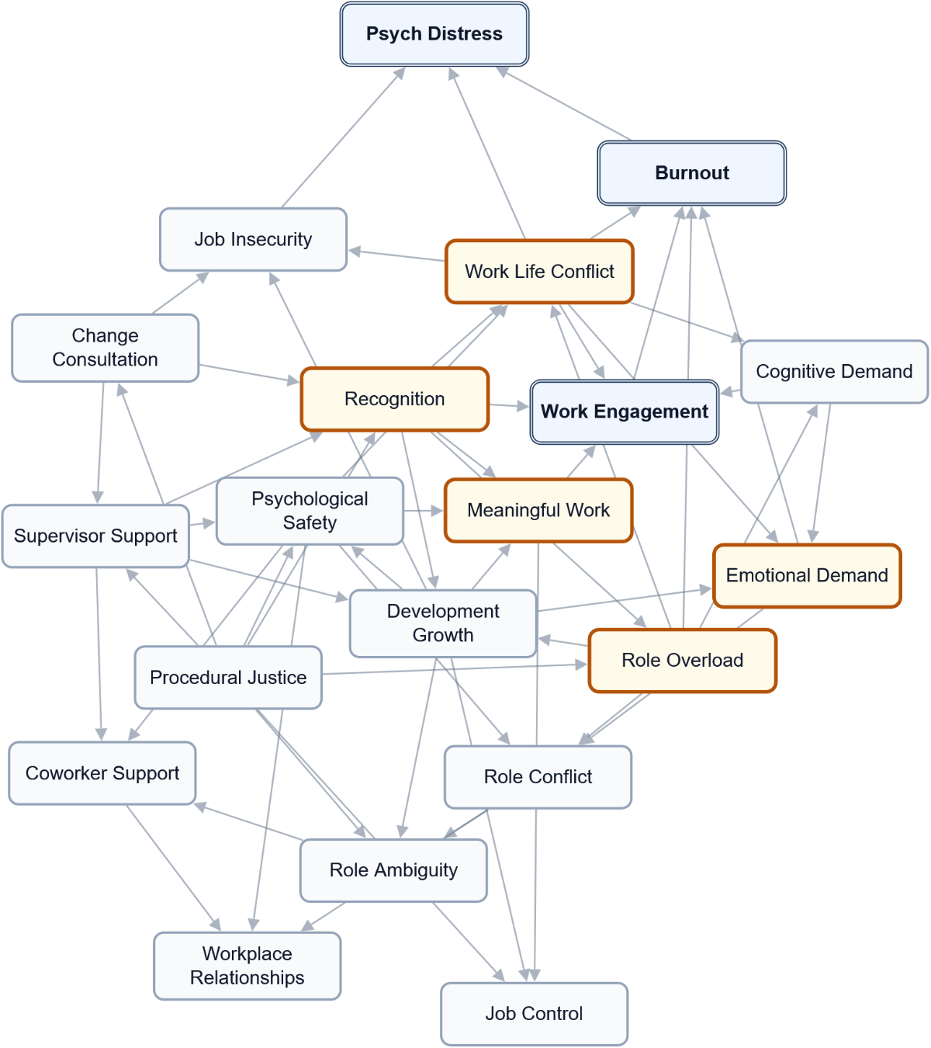

A2 – Starting Model Estimates
Starting probabilities from the report model, before a scenario is applied. These are model estimates, not raw response counts. State labels and any recorded direction are shown for each factor. Not applicable means the factor does not use that state; unavailable means its probability was not supplied.
Factor | Low (L) | Moderate (M) | High (H) | Recorded direction
Burnout | 33.3% | 41.1% | 25.5% | Lower is favourable
Change Consultation | 28.4% | 43.7% | 27.9% | Higher is favourable
Cognitive Demand | 12.5% | 45.2% | 42.3% | Lower is favourable
Coworker Support | 15.7% | 42.0% | 42.2% | Higher is favourable
Development Growth | 14.1% | 37.8% | 48.1% | Higher is favourable
Emotional Demand | 45.3% | 33.1% | 21.6% | Lower is favourable
Job Control | 24.3% | 48.0% | 27.7% | Higher is favourable
Job Insecurity | 55.8% | 28.9% | 15.4% | Lower is favourable
Meaningful Work | 14.5% | 30.6% | 54.9% | Higher is favourable
Procedural Justice | 17.0% | 39.5% | 43.5% | Higher is favourable
Psych Distress | 45.4% | 36.2% | 18.4% | Lower is favourable
Psychological Safety | 11.5% | 38.6% | 49.9% | Higher is favourable
Recognition | 16.8% | 33.3% | 49.9% | Higher is favourable
Role Ambiguity | 66.0% | 28.7% | 5.3% | Lower is favourable
Role Conflict | 41.1% | 36.8% | 22.1% | Lower is favourable
Role Overload | 27.9% | 46.9% | 25.2% | Lower is favourable
Supervisor Support | 20.8% | 36.9% | 42.4% | Higher is favourable
Work Engagement | 18.5% | 47.4% | 34.1% | Higher is favourable
Work Life Conflict | 45.5% | 34.3% | 20.2% | Lower is favourable
Workplace Relationships | 11.1% | 32.1% | 56.8% | Higher is favourable

A3 – Simple Scenarios: One Factor at a Time
Each row compares a hypothetical change in one workplace factor with the starting model. Related conditions can change in the calculation; they are not all held fixed. The exact comparison state is shown where recorded. Positive values increase the named outcome state, which is favourable only where stated. The summed score adds changes across outcomes and is not a share of workers. Do not add separate rows to predict a joint effect.
Factor / scenario state | Work Engagement  H (favourable)  Change (pp) | Burnout  L (favourable)  Change (pp) | Psych Distress  L (favourable)  Change (pp) | Sum (points)
Role Overload  Scenario state: L | -1.1 pp | +19.2 pp | +10.9 pp | +29.0 points
Work Life Conflict  Scenario state: L | +6.5 pp | +9.2 pp | +12.1 pp | +27.8 points
Recognition  Scenario state: H | +10.8 pp | +5.5 pp | +3.6 pp | +19.9 points
Meaningful Work  Scenario state: H | +12.0 pp | +4.2 pp | +1.7 pp | +17.9 points
Procedural Justice  Scenario state: H | +5.8 pp | +4.5 pp | +3.4 pp | +13.8 points
Emotional Demand  Scenario state: L | +0.0 pp | +7.9 pp | +3.5 pp | +11.4 points
Supervisor Support  Scenario state: H | +5.5 pp | +2.6 pp | +2.0 pp | +10.1 points
Psychological Safety  Scenario state: H | +3.2 pp | +1.9 pp | +1.7 pp | +6.8 points
Change Consultation  Scenario state: H | +3.1 pp | +1.5 pp | +2.2 pp | +6.7 points
Development Growth  Scenario state: H | +3.8 pp | +0.5 pp | +1.0 pp | +5.4 points
Job Insecurity  Scenario state: L | +0.0 pp | +0.0 pp | +4.3 pp | +4.3 points
Coworker Support  Scenario state: H | +0.0 pp | +0.0 pp | +0.0 pp | +0.0 points
Job Control  Scenario state: H | +0.0 pp | +0.0 pp | +0.0 pp | +0.0 points
Role Ambiguity  Scenario state: L | +0.0 pp | +0.0 pp | +0.0 pp | +0.0 points
Role Conflict  Scenario state: L | +0.0 pp | +0.0 pp | +0.0 pp | +0.0 points
Workplace Relationships  Scenario state: H | +0.0 pp | +0.0 pp | +0.0 pp | +0.0 points
Cognitive Demand  Scenario state: L | -18.4 pp | -4.3 pp | -1.5 pp | -24.3 points

A4 – Combined Scenarios: Factors Moved Together
These scenarios compare several changes together with the starting model. Their joint effect may be larger or smaller than the sum of separate comparisons. The calculation alone does not establish why, how quickly benefits would appear, or whether an action is feasible. Read each outcome separately.

Top combined scenarios: Work Engagement
H (favourable). Up to five supplied combinations, ranked by this outcome's change rather than the summed score. This is not an exhaustive search of all possible changes.
Factors compared together | Starting share | Scenario share | Change (pp)
Work Life Conflict (L) + Recognition (H) + Meaningful Work (H) | 34.1% | 64.0% | +29.8 pp
Work Life Conflict (L) + Procedural Justice (H) + Meaningful Work (H) | 34.1% | 58.1% | +24.0 pp
Recognition (H) + Meaningful Work (H) + Psychological Safety (H) | 34.1% | 58.0% | +23.9 pp
Work Life Conflict (L) + Supervisor Support (H) + Meaningful Work (H) | 34.1% | 57.8% | +23.6 pp
Supervisor Support (H) + Recognition (H) + Meaningful Work (H) | 34.1% | 57.5% | +23.3 pp

Top combined scenarios: Burnout
L (favourable). Up to five supplied combinations, ranked by this outcome's change rather than the summed score. This is not an exhaustive search of all possible changes.
Factors compared together | Starting share | Scenario share | Change (pp)
Role Overload (L) + Emotional Demand (L) + Meaningful Work (H) | 33.3% | 66.1% | +32.7 pp
Role Overload (L) + Emotional Demand (L) + Recognition (H) | 33.3% | 65.5% | +32.1 pp
Role Overload (L) + Emotional Demand (L) + Work Life Conflict (L) | 33.3% | 64.9% | +31.6 pp
Role Overload (L) + Work Life Conflict (L) + Meaningful Work (H) | 33.3% | 64.2% | +30.8 pp
Role Overload (L) + Emotional Demand (L) + Procedural Justice (H) | 33.3% | 63.3% | +30.0 pp

Top combined scenarios: Psych Distress
L (favourable). Up to five supplied combinations, ranked by this outcome's change rather than the summed score. This is not an exhaustive search of all possible changes.
Factors compared together | Starting share | Scenario share | Change (pp)
Role Overload (L) + Work Life Conflict (L) + Job Insecurity (L) | 45.4% | 66.8% | +21.4 pp
Role Overload (L) + Emotional Demand (L) + Work Life Conflict (L) | 45.4% | 64.9% | +19.5 pp
Role Overload (L) + Work Life Conflict (L) + Meaningful Work (H) | 45.4% | 64.8% | +19.4 pp
Role Overload (L) + Work Life Conflict (L) + Change Consultation (H) | 45.4% | 64.6% | +19.2 pp
Role Overload (L) + Work Life Conflict (L) + Recognition (H) | 45.4% | 64.5% | +19.0 pp

A5 – Methodology and How to Read These Tables
These are estimates from the supplied model. No response-fitting record is available in this export. A sector label alone does not establish a survey source or representative sector observations. The recorded information does not establish a measured baseline for this workplace.
Factors use the state labels recorded in the supplied model; they need not all use the same scale. Scenarios are hypothetical planning comparisons, not promises of achievable change or proof of causation. Changing one factor can also change related factors. Percentages describe the selected state; percentage points describe differences. A summed outcome score is a comparison score, not a percentage of workers.
Numerical uncertainty ranges are not available. Consider answer coverage, the model's source and worker consultation when deciding what to do. Use Data Analytics to explore other factors and scenarios.
Displayed values are rounded. Complete distributions may not total exactly 100%, and changes or summed scores may differ slightly from calculations using the displayed figures.

